**1.routes\web.php**

<?php

/*

|--------------------------------------------------------------------------

| Web Routes

|--------------------------------------------------------------------------

|

| Here is where you can register web routes for your application. These

| routes are loaded by the RouteServiceProvider within a group which

| contains the "web" middleware group. Now create something great!

|

*/

//Route::get('/', function () {

// return view('welcome');

//});

Auth::routes();

//Route::get('/home', 'HomeController@index')->name('home');

**Route::name('home')->get('/', 'ShopController@index');**

**2.app\Http\Controllers\ShopController.php (for example from ProductController.php from lesson)**

<?php

namespace App\Http\Controllers;

use Illuminate\Http\Request;

class **Shop**Controller extends Controller

{

/**

* Create a new controller instance.

*

* @return void

*/

public function __construct()

{

//$this->middleware('auth');

}

/**

* Show the application dashboard.

*

* @return \Illuminate\Contracts\Support\Renderable

*/

public function index()

{

return view('**shop**.index');

}

}

**3.**resources\views\**shop\index.blade.php (in resources\views create dir shop)**

<h3>Home</h3>

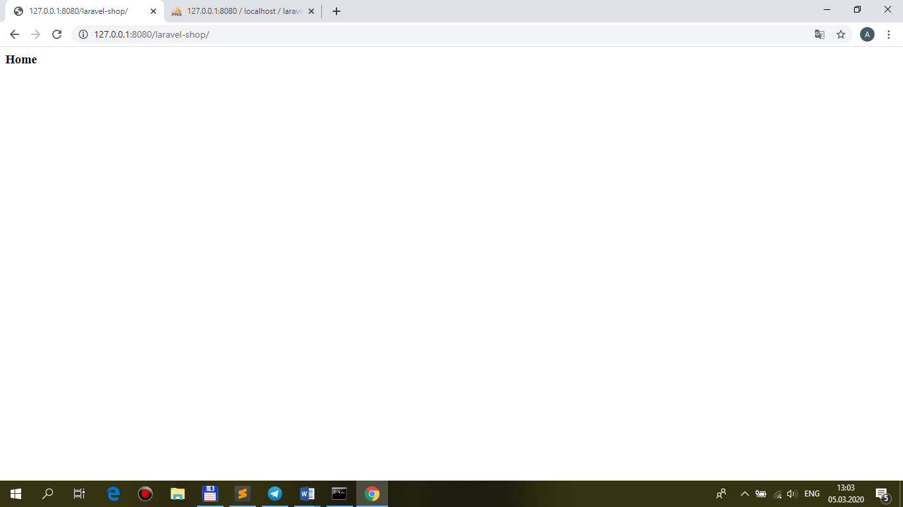

**4.**resources\views\**shop\layout.blade.php (in YOUR Template – HEADER, FOOTER, PUBLIC (css, js, images…), asset (for css, js !AND images))**

**5.**resources\views\**shop\index.blade.php**

@extends('**shop.layout**')

@section('**main**')

<h3>Home</h3>

@endsection

…**index.html** from **template** (see **url**)

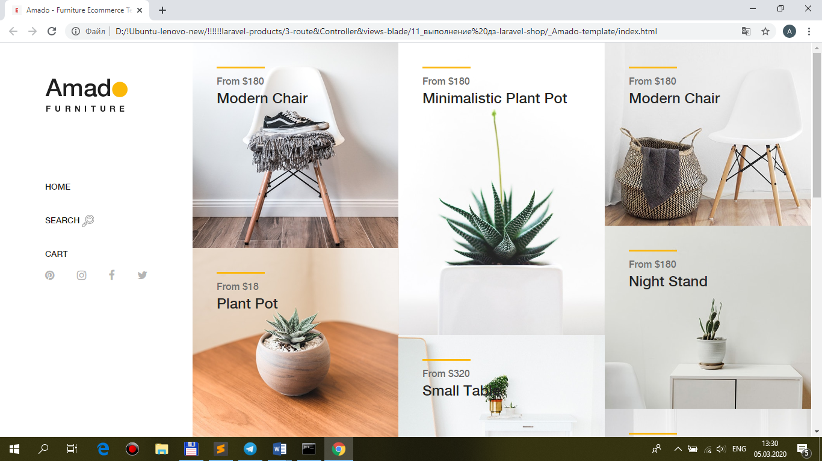

…and **127.0.0.1:8080/laravel-shop** (see **url**)

